Angel Fernandez
CS-230: Operating Platforms
October 28, 2025
SNHU
1-5 Assignment: UML Diagrams
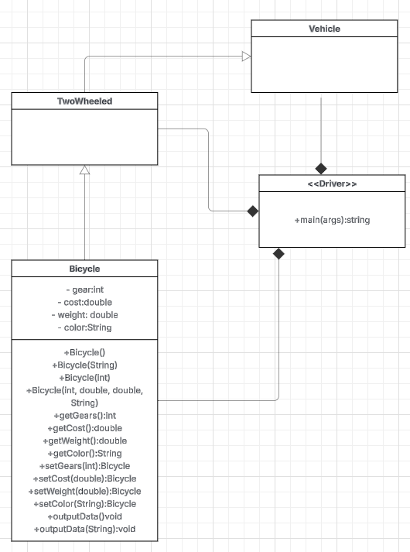
We can see that the Driver contains the main() class and calls to the other classes because it is needed to make the program run, all the other classes link to it as compositions, meaning they cannot exist without the Driver class. Bicycle is an extension to the TwoWheel class, which is also an extension to the Vehicle class. This means that the TwoWheel class will inherit all the attributes and functions from the Vehicle class, it is the same for the Bicycle class with the TwoWheel class. The attributes are private which you can see with the “-“ (minus signs) cand can only be accessed by the Bicycle class, the functions are public and can be seen with the “+” (plus signs)

